Subject: | Re: Samuel Grigg's Cem.
Date: | 10/12/2007 4:06:26 PM Central Daylight Time
From: | ladybugsboo@yahoo.com
To: | WayneAL1@aol.com

Here is a good map I found online, it is copy righted by Kenny Jones.. but you can look at it, it is of Dist
6 in 1878, at the bottom of the county, next to Giles, you see a P. H. Grigg, this is the farm place. Patrick
Henry Grigg inherited the farm from his father with he died...Great map.
Samuel bought the land in 1812 and it stayed in the
family till about 1915.
Linda

Nice find Linda. I did not think to look on that map. It shows clearly the PH Grigg place. There are slight errors in the placement of assets on that map. Some houses and roads are difficult to pinpoint against highly accurate topographical maps today though the map shows the historical assets very well.

That is Gary Hoods site I will use a cropped portion of the map and he won't care. I know him well. Besides I have a hard copy of the map too and could scan it. They can't really copyright the map. Only the way it is presented in protected.

Just looking at that one would believe the farm was back near the Elkridge at the headwaters of the branch as related earlier, so the graveyard is probably back of that closer to the ridge on a plateau maybe?

The Ella West Road is placed in about the same position so I bet this cemetery could be found.
The winter this year will be great to find old lost cemeteries. The vegetation is as low as I have ever seen it. We are in a Record breaking drought. Almost desert like here as we are nearly 30 inches behind in rain fall. I been jokingly telling folks we are living in the Great Southern Desert. If the rains do not come stirring the vegetation before the cold kills it I will have a great opportunity to find some lost cemeteries this winter.

If I could see the shape and lay of the land owned by the Grigg that would also be a clue as they started these old family cemeteries on the back side of the property on a hill or ledge away from flooding. It may be located at the headwaters of the creek around the same elevation somewhere assuming the Grigg family owned that property. It is quite possible they lost several children before they found a memorial stone supplier to purchase stones from that would allow them install those in the cemetery, so that often caused them to pick a spot in haste. That is just the way it was.

Owners of the old antebellum properties though usually put their graveyards closer to the home on the nearest hilltop close to the backside of the house. In one case I know of the cemetery is out near the lane from the main road to the house. All that was so because death was so prevalent that they often had several children die before one would live to adulthood. Generally if you know of an old antebellum home older than 1850 there is a nearby graveyard affiliated with the old home.

Wayne A.

Subject: | Samuel Grigg's Cem.
Date: | 10/12/2007 1:30:22 PM Central Daylight Time
From: | ladybugsboo@yahoo.com
To: | WayneAL1@aol.com

HI,
I am sure no one ever mapped it other than the
descendants that lived there and went back to visit
it. The one person I knew that would know how to get
there died many years ago. The maps might help.
If I could find a mailing address that would a least
find the farm. I will keep asking around maybe someone
knows something more.
Thanks for all your effort and help.
Linda

--- WayneAL1@aol.com wrote:
I may put that land info on the site as an aid to
help someone find the cemetery if you don't mind. I also will put the maps out there I made up.
Yes I use the best available maps known for this. However the Grigg cemetery does not show up in any of them. It has not been turned in to the Geological Mapping Survey agency so that is why it is not showing up on any maps. Only about 60% of the cemeteries in Maury County show up on mapping surveys and maybe about half of those are places incorrectly on
the map to some degree.
I would go there and try to find it but I know how hard it can be to find a small cemetery like that. The thickets tend to grow over the stones. One can be standing within 20 feet of a cemetery and still miss it. I still may go there sometimes to try because it looks very rural and at least I probably will not get shot at for going there. HA
Wayne

Subject: | Re: Samuel J Grigg wrong date on stone
Date: | 10/11/2007 10:15:06 PM Central Daylight Time
From: | ladybugsboo@yahoo.com
To: | WayneAL1@aol.com

My mother is a Grigg, I am happy to be able to save the information for future generations, thank you for
posting the cemeteries. They help everyone doing genealogy.
You are right on the location of the Grigg farm. On the other side of the line in Giles Co., Tn is the
brother to Samuel Grigg, Amasa Burton Grigg. I found Griggs Hollow a few months back and was excited to
find it on the map. Your maps are better than the one I found. Culleoka was the closest town or PO.
Campbells'station was close by.
1813
Land Deeds of Tennessee
This is from Deed Book "E" p. 81
Joseph Braden of Williamson to Samuel Grigg of Maury, for $103, 75 acres on headwaters of E. fork Fountain Cr., running with line between John and Joseph Braden.
Wit: Jacob Montgomery, Samuel Wood.
Dated: Jan. 1, 1812.
Reg: Apr. 6, 1813 Joseph Braden
Tax records...descriptions...
South side of Duck River.
River counties
135 acres of School land
Adams fork of fountain creek
He owed about 325 acres at the time of his death.
I know all of his neighbors from the census records.
This pretty well places the area of the Grigg Cemetery.
Thanks,
Linda
--- WayneAL1@aol.com wrote:
OK I got the Grigg Cemetery posted on line. Check it out and let me know if I can improve anything.
http://freepages.genealogy.rootsweb.com/~maury/cemetery/GriggCemetery/GriggCemetery.htm
I am tickled to get a rare cemetery never before posted in any records.
Thanks a bunch Linda.
I also think I may know the area the cemetery may be found in. There is no branch of the Fountain creek that goes over the Elk Ridge into Giles County, but there is one small branch just about at the end of the creek that runs down from the Elk Ridge and creates a Hollow (called by southerners a "Holler"). There is a Griggs (Holler) Hollow running up that Branch. Hollow just means between two Ridges or hills and usually lies down in a valley with a stream flowing through it. Attached are two maps showing the place. It is between Highway 31 and the Dodson Gap road and the Tanyard Hollow Road. It can best be accessed I think by coming north up Ella West Road from Hwy 129 in Giles County and when the road turns east park and walk northwest over the ridge and into the Griggs Hollow and follow along that branch north east and I bet is it along that branch the cemetery might be found. That is if the brush is low in the dead of the winter.
Wayne Austin
Subject: | Grigg Family Cem. Maury Co.,Tn.
Date: | 10/9/2007 10:03:29 PM Central Daylight Time
From: | ladybugsboo@yahoo.com
To: | WayneAL1@AOL.com

Hi Wayne,
I have a picture of the little cemetery of Grigg Homeplace. I did have most of the stones upclose but
lost them to computer failing, but still have a few of them.
I can email for posting online.
Linda
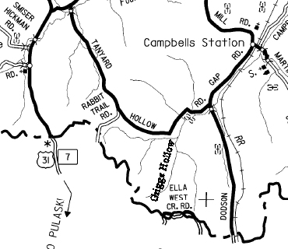
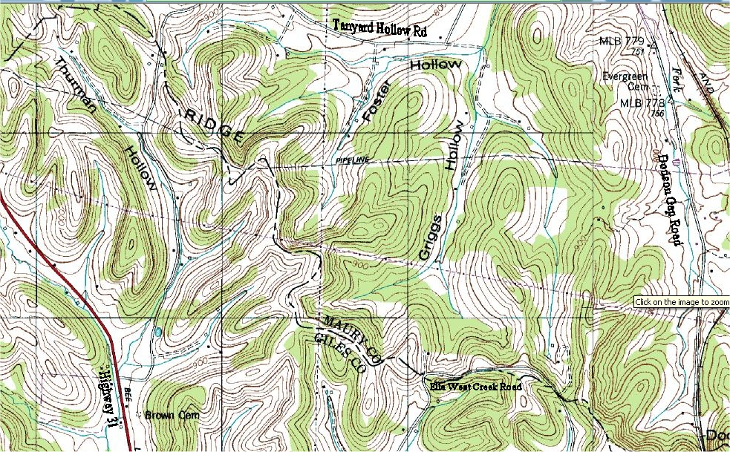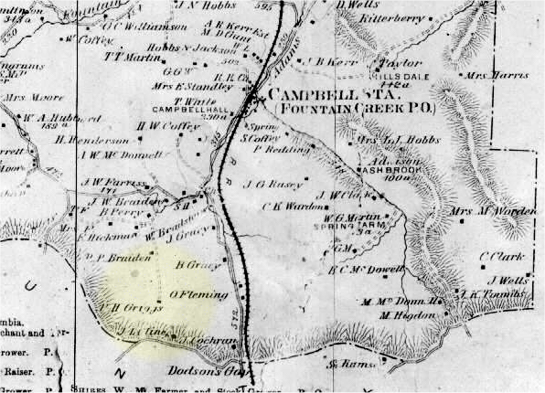
Notice the P H Grigg place down near the Giles County Line.

